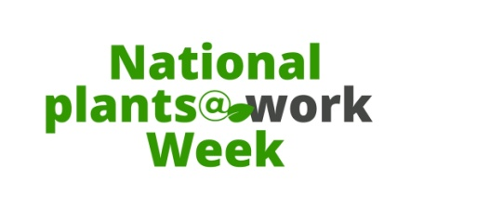

Your Letterhead or logo

PRESS RLEASE
July 2019

10 reasons why plants in the workplace are beneficial
National Plants@Work Week

Next week 8 - 12 July 2019, during National Plants@Work Week (NPWW), (name of your company) will be taking part (explain what you are doing to promote plants and NPWW).

National Plants@Work Week has named 10 good reasons to have plants in your workplace including:
- Our biological need to connect with nature called biophilia
- To help clean and refresh the air inside and also reduce dust particles
- To help keep our stress levels manageable
- To act as a happiness barometer - research tells us that plants help to lift our spirits
- Amazingly being surrounded by plants also raises our productivity levels - a good reason for any employer to invest
- If you need help with concentration, invest in some interior planting as it can improve it by 23% and more
- Plants can deflect and diffract sound especially in open plan offices
- Having plants around improves humidity levels helping to keep us comfortable
- Green walls can help to buffer outside noise as well as insulate the building
- Green roofs offer thermal insulation and a good view for your neighbours which is good for them too according to research

All of these facts have been backed up by scientific and academic research over the last 30 years. We take plants for granted and don't consider how reliant on them we are.

Maximising on Health & Wellbeing
With wellbeing at the forefront of most business' plans, which one wouldn't want the added bonus of maximising productivity and reducing time taken off sick too? Not to mention reducing any pollution in the air.

It is a well-known fact that we spend more time indoors than outdoors (roughly 90% indoors) and that air pollution indoors can be 10 times more polluted than outdoor air (Environment Protection Agency - EPA). Scarier are statistics that suggest that polluted air can cause premature deaths according to the World Health Organisation (WHO) and The Royal College of Physicians.

Let's make workplaces greener and healthier
If you want to learn more see (your website/attached leaflet or card) about how plants can have a positive influence on your life. You can also follow the activities of National Plants@Work Week on Facebook, Twitter and Instagram using #plantsatworkweek.

Ends

Your company name
For more information please contact, (your company contact and company name)

Contact details
Tel
Email
Company website

National Plants@Work Week
For more information about National Plants@Work Week, please contact Coll Smith Marketing Coordinator at National Plants at Work Week (an Plants at Work Ltd formerly efig Ltd initiative) via

Tel: 01722 504565
Mob: 07758 215661
Email: marketing@plantsatwork.org.uk

www.plantsatwork.org.uk

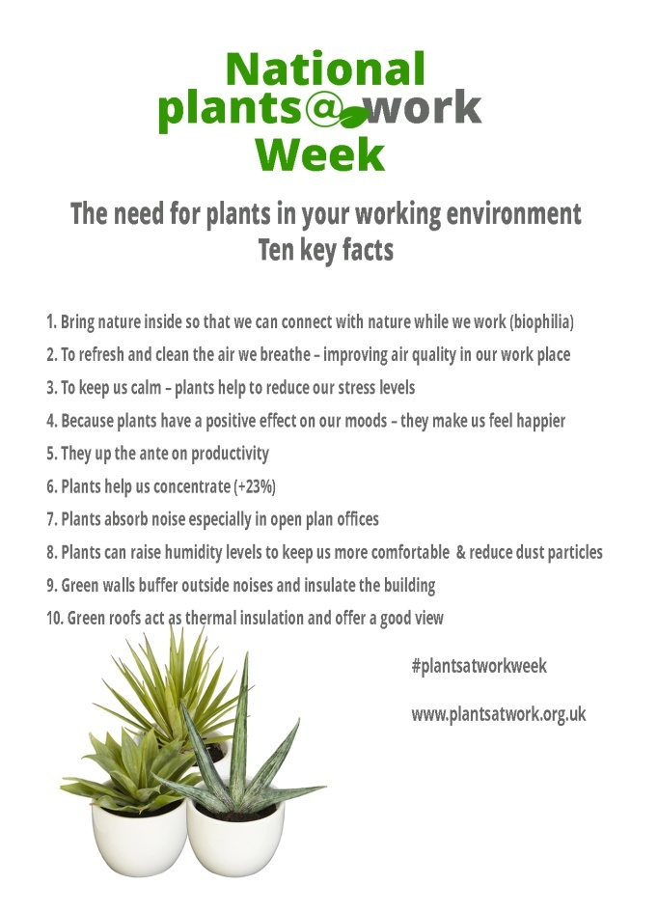

(You can use the postcard back as the image to go out with this release if you need to)
Editor’s notes
National Plants at Work Week is an annual event to raise awareness of the benefits of plants to the working environment. 2019 is the seventh consecutive annual event.

12.5 million working days lost to absence caused by stress and depression in 2016-17, part of 137.3 million working days lost overall. (HSE & ONS)

2. 7 million premature deaths annually linked to air pollution, WHO, 25 March 2014.
http://www.who.int/mediacentre/news/releases/2014/air-pollution/en/

Indoor air more polluted than air outside http://www.epa.gov/region1/communities/indoorair.html

Research synopsis about the benefits of plants downloadable from the plantsatwork website

